**Mini Project**

**Keystone School Of Engineering Date: ______**

**T.E E&TC (2019 pattern)**

**Group No 8:**

Ayman Attar – 27

Sumedh Pathrudkar - 14

Bhagyashri Kalkure - 30

***Topic : GSM Based Water Pump Control System***

***Abstract:***

In present days, we prefer automation in every sector. Automated systems are bendy to use. It offers large precision and consistency with high term operation as fair as the manual operated systems. Our proposed system is the automation of the **Electric Water Pump** used in households, industries, agriculture etc. Our effort is to make and achieve the mechanization implementation to manage electrical motor with the help of **GSM** module. With this the user can monitor the Water Pump by just sending commands through the SMS. The demonstration given here is of the agriculture use case. The main contribution of this work is to offer **automatic water supply for plants** to saving time as well as water. This will ease the work of farmers as they can monitor the Water Pump by just sending commands through SMS which will reduce their physical work.

The proposed system is controlled by **Arduino** to turn ON/OFF of pump by checking the moister level with the help of **moisture sensors**. In this work, the **GSM technology** is also used to switch ON/OFF of the pump using mobile phone by sending the commands to the kit through the GSM modem.

***Introduction:***

Agriculture based economy could lead a country towards an economically independent nation. Undoubtedly, India is an agricultural country, and its economy depends on farming. One of the essential elements for successful farming is that we should lighten the burden on the farmers so that their productivity level can be increased. We can reduce the burden on farmers by automating the water supply system. That’s not a lot but can be helpful. Our proposed system does the same. It automates the monitoring of the water supply and water requirements of the plants with the help of specific sensors.

In the traditional water supply system the farmer would have to monitor the water supply by himself and would have to turn on and off the water pump accordingly. But in thwi system the controller will do the work for farmer. It will continuouslymonitpr the moisture in the soil and if the moisture level goes down below certain level the controller will itself turn on the water pumo. Besides the system also gives the farmer full controll of the water pump. He can turn on and off the pump whenever it is necessary by just sending a text message through his mobile phone.This will not only lighten the burden of the farmer but also will help him reduce the wastage of water and much more.

***Literature Survey:***

**Mr.M.Suresh , S.Ashok , S.Arun Kumar** and **Puppala Sairam** published an article named **Smart Monitoring of Agricultural Field And Controlling of Water Pump Using Internet of Things** in year 2019. The article proposed to make and achieve the mechanization implementation to manage electrical motor which is used in agricultural domain. In The proposed system that enables us to power the devices over GSM base and can translate the signals from the associated sensors in the ground and electrical parameters that can be sent to the user.

This supported system was based on the arrangement of the sensors. Some of measures which are followed to reduce the misuse of water and also to avoid wastage of electricity. The methodology is embedded in gate way network making scheme, a smart and self-governing wireless decision system support. Water economy methods which are based on the threshold parameters were improved utilization of the irrigated stream to reduce the percolation phenomenon without effecting quality of crop.

The smart mobile which works on Android is said to communicate with the microcontroller. The primary work of the farmer is to control the motor device and get the Specifications on the mobile device. The GSM based SIM 900 module interacts between the smart mobile and the microcontroller. The mobile communicates with the arduino wireless microcontroller using GSM. The GSM module will send and receive the voice calls through a microcontroller. The commands are used to transfer the data specifications. The module is integrated with Transmission control protocol.

***Block Diagram:***

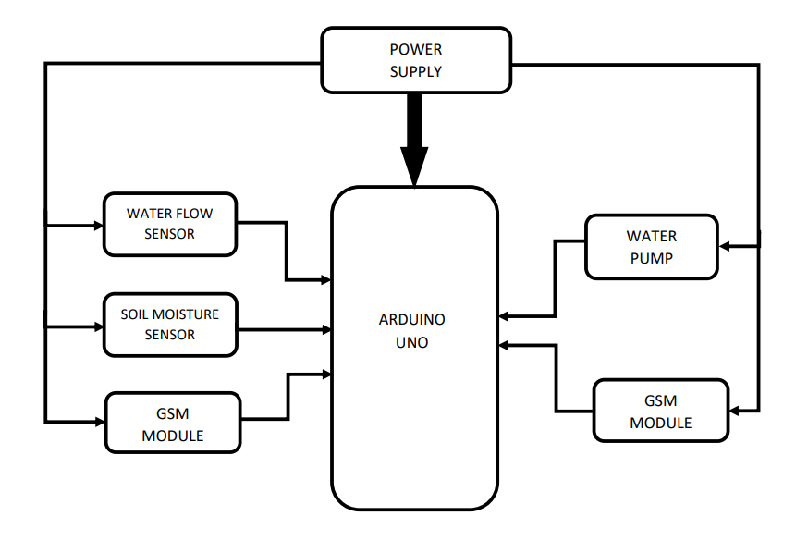

***Advantages:***

* Use of this system will save farmers time and money.
* Reduces te burden of farmers also increases their productivity.
* Farmers can control land moisture from a remote location.
* It can be easily implemented in the fields.
* It is user friendly

***Applications:***

* This system can be used in the agricultural watering pumps.
* It also has wide applications in the industrial as well as household water pumps

***Future Scope:***

* Addition of IOT to the system would give great outcomes.
* PLC version can also be designed for factories.